

Table of Contents

Abstract 4

INTRODUCTION 4

VARIABLE EXPLANATION: 5

**Functional Form of the Model:** 5

**Hypothesis** 6

DESCRIPTIVE STATISTICS: 6

HISTOGRAM TABLES: 8

**Dependent Variable** 8

**Independent Variables:** 9

Q-Q PLOTS: 10

**NASDAQ** 10

**BITCOIN** 10

**ETHEREUM** 11

**LITECOIN** 12

**GBTC** 12

**EUR/USD** 13

JARQUE-BERA TEST: 13

CORRELATION ANALYSIS: 14

CORRELATION MATRIX: 15

CORRELATION MATRIX EXPLAINED: 15

CORRELATION BETWEEN VARIABLES: 15

**NASDAQ vs. CRYPTOCURRENCIES CORRELATION** 15

**INTER-CRYPTOCURRENCY CORRELATION**: 16

STATIONARITY OF VARIABLES: 17

MULTIPLE REGRESSION ANALYSIS: 17

Interpretation: 18

**Coefficients:** 18

**Significance:** 18

**Model Fit:** 20

DIAGNOSTIC TESTS 21

MULTICOLLINEARITY 21

VARIANCE INFLATION FACTOR (VIF) 21

TABLE FOR VIF 21

EXPLANATION 21

HETEROSCEDASTICITY 22

**WHITE TEST** 22

23

**BREUSCH-PAGAN-GODFREY TEST** 24

**HARVEY TEST** 25

AUTOCORRELATION 26

**DURBIN WATSON TEST** 26

**DURBIN WATSON -h TEST** 27

Ramsey RESET Test 29

**CORRELOGRAM OF RESIDUALS** 30

**JOHANSEN CO-INTEGRATION TEST** 31

**TRACE TEST** 32

**RANK TEST** 32

**Vector Error Correction Model (VECM)** 33

**Granger Casualty Test** 34

MODEL SELECTION: 35

**ARMA/ARIMA Modelling** 35

**INSTRUCTIONS:** 35

**Model Selection (ARMA vs. ARIMA):** 35

**Checking Stationarity:** 35

**Parameter Selection:** 36

**APPLICATION:** 36

**Nasdaq (NDX):** 36

**ARIMA (5,1,5)** 40

**ARIMA (35,1,35)** 41

**ARIMA (5,1,35)** 42

**FORECASTING:** 43

**GRAPH EXPLANATION** 43

• **CONFIDENCE INTERVAL:** 44

**TABLE EXPLANATION** 44

CONCLUSION: 45

REFERENCES: 46

# Abstract

By examining the cross-correlations between the two most valuable cryptocurrencies, Bitcoin (BTC) and Ethereum (ETH), this research paper focuses on how cryptocurrencies affect traditional stock market indices. However, Litecoin (LTC) has also been a significant factor in the study. By examining the increasing potential for institutional involvement in the cryptocurrency region, we hope to analyse the impact of the cryptocurrency field's growing capitalization on the stock market as a whole.

This study looks at the long-term relationship between cryptocurrencies and the traditional stock market. As exchange rates have been rising and falling over time, and as institutional involvement in this industry has grown, we have looked at various models that explain and describe the relationships between these variables that help us with our research. Since more and more individuals and businesses are investing in cryptocurrencies, institutional involvement has been a significant factor. In the near future, we can also anticipate cryptocurrencies playing a significant role in the economy due to their rapid, exponential growth. Our analysis looks at how cryptocurrencies have the potential to be a significant turning point and how institutional investment in this space will impact the conventional stock market as well.

# INTRODUCTION

The data that we have sourced from [investing.com](https://www.investing.com/), is of the following:

1. NASDAQ 100 (NDX) – Traditional stock market representation
2. BITCOIN (BTC) – The largest cryptocurrency in the market
3. ETHEREUM (ETH) – A leading blockchain platform with smart contracts
4. LITECOIN (LTC) – One of the earliest Bitcoin alternatives
5. Grayscale Bitcoin ETF (GBTC) – One of the biggest crypto ETFs in the world.
6. EUR/USD – The exchange rate of Euros and US Dollar.

With a timeframe spanning from May 2017 to October 2024, the data offers a solid framework for examining the potential effects of cryptocurrencies on the conventional stock market over time. The data's weekly frequency guarantees that long-term trends are prioritized while short-term market noise is eliminated.

Understanding the relationship between cryptocurrencies and the conventional stock market is the aim of this investigation, which also looks at whether cryptocurrencies have a discernible and substantial influence on stock market indices such as the NASDAQ 100. This study investigates the interactions and influences that have occurred over time between the cryptocurrency environment and the conventional stock market.

# VARIABLE EXPLANATION:

## **Functional Form of the Model:**

The econometric model can be expressed as:

**NASDAQ=**β0+β1(BTC)+β2(ETH)+β3(LTC)+β4(DOGE)+ U

**Where:**

* **NASDAQ:** Dependent variable, representing the stock market index.
* **β0:**Constant term (intercept), capturing the baseline level of the NASDAQ index when all other variables are zero.
* **BTC:** Explanatory variable for Bitcoin prices.
* **ETH:** Explanatory variable for Ethereum prices.
* **LTC**: Explanatory variable for Litecoin prices.
* **DOGE**: Explanatory variable for Dogecoin prices.
* **β1,β2,β3,β4**: Coefficients of the explanatory variables, representing the marginal impact of each cryptocurrency on the NASDAQ index.
* **U:** Error term, accounting for unobserved factors affecting NASDAQ.

## **Hypothesis**

* **Null Hypothesis** (Ho: The explanatory variables (BTC, ETH, LTC, DOGE) have no significant impact on the NASDAQ index.
* **H0**: βBTC=βETH=βLTC=βDOGE=0
* **Alternative Hypothesis H1**: At least one of the explanatory variables has a significant impact on the NASDAQ index.
* **H1**:At least one β≠ 0

# DESCRIPTIVE STATISTICS:

In this section of the report, we discuss the descriptive statistics of the variables taken in our study and analyse all of them to see if they are acceptable or meet set standard which is, Normality.

Normality refers to whether the data follows a normal distribution (bell shaped curve). It also involves checking if the data has properties like symmetry around the mean and specific kurtosis and skewness values. Normality is important to further proceed with our analysis and moving on to liner regression and other models.

For better understanding and results being consistent, we take logs of the variables and use all the information in that order so we can achieve optimal skewness and kurtosis, which infers that the variables are normal and are a fit for this model for further analysis.

|  |  |  |  |  |  |
| --- | --- | --- | --- | --- | --- |
| Name | Mean | Median | Std. Deviation | Skewness | Kurtosis |
| NDX | 9.285207 | 9.370836 | 0.370466 | -0.113446 | 1.690794 |
| BTC | 9.745074 | 9.853644 | 0.925030 | -0.160306 | 1.856700 |
| ETH | 6.693582 | 7.105831 | 1.144797 | -0.224778 | 1.551545 |
| LTC | 4.389632 | 4.288105 | 0.511719 | 0.502912 | 2.832180 |
| GBTC  EUR/USD | 2.803711  0.116854 | 2.656405  0.114266 | 0.733260  0.050394 | 0.133763  -0.238765 | 2.064442  2.840106 |

**Interpretation of Mean vs. Median:**

A near mean and median indicate that the data is reasonably symmetrical. Skewness is indicated by larger discrepancies.  
The mean and median for all of the variables (NDX, BTC, ETH, GBTC, EUR/USD and LTC) are rather close, suggesting moderate symmetry.

**For Skewness:**

* Skewness = 0: A distribution that is perfectly symmetrical.
* Skewness < 0: Left-skewed, meaning the left tail is longer.
* Skewness > 0: Right-skewed, meaning the right tail is longer

Here,

* NDX: Shows a slight inclination toward lower values, with a slightly left-skewed value of -0.113.
* BTC: Shows a slight asymmetry, with a slightly left-skewed value of -0.160.
* ETH: Displays a longer left tail and is moderately left-skewed (-0.224).
* LTC: More extreme high values are present because it is right-skewed (0.503).
* GBTC: Near symmetry, as indicated by being quite close to 0 (0.133).
* EUR/USD: Displays a longer left tail and is moderately left-skewed (-0.238765).

**For Kurtosis:**

* Kurtosis = 3: Normal distribution (mesokurtic).
* Kurtosis > 3: Leptokurtic (sharper peak, heavier tails).
* Kurtosis < 3: Platykurtic (flatter peak, lighter tails)

Here,

* NDX: 1.69: Platykurtic, which denotes a flatter peak and lighter tails.
* Bitcoin: Platykurtic, 1.86, with comparable traits.
* ETH: 1.55: Platykurtic, meaning tails are lighter.
* LTC: 2.83: This value is close to normal but leptokurtic, indicating slightly heavier tails.
* GBTC: 2.840106: This value is close to normal but leptokurtic, indicating slightly heavier tails.

So far, these are the descriptive statistics for every variable in this model.

Moving on we have the histogram tables for all the variables in the next figure.

## HISTOGRAM TABLES:

### **Dependent Variable**

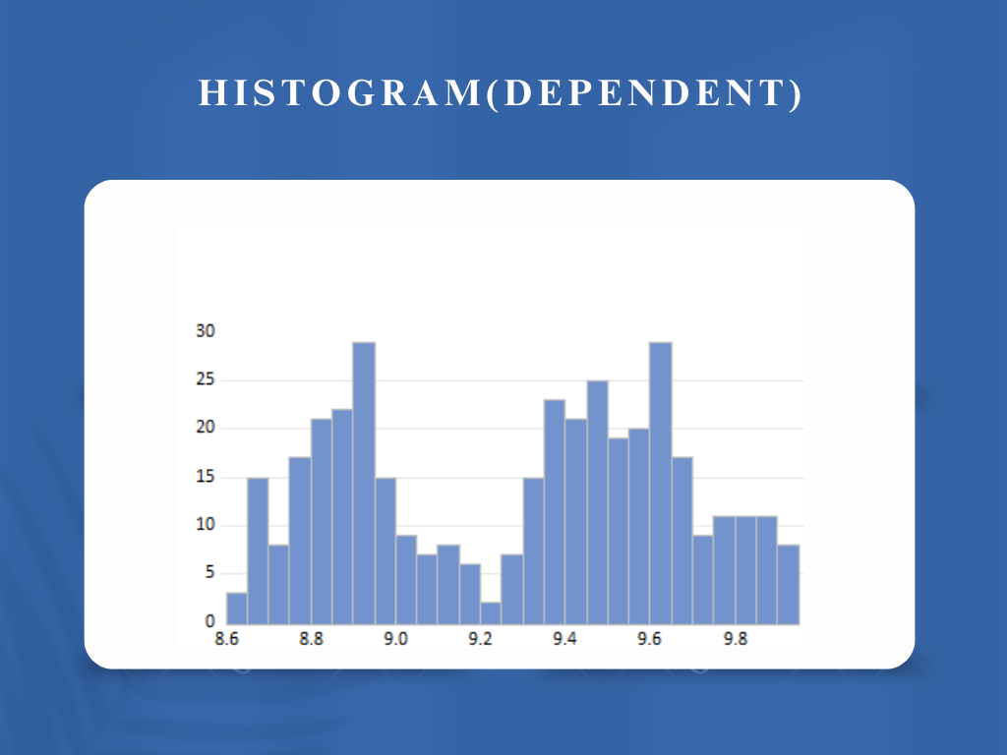

**Independent Variables:**

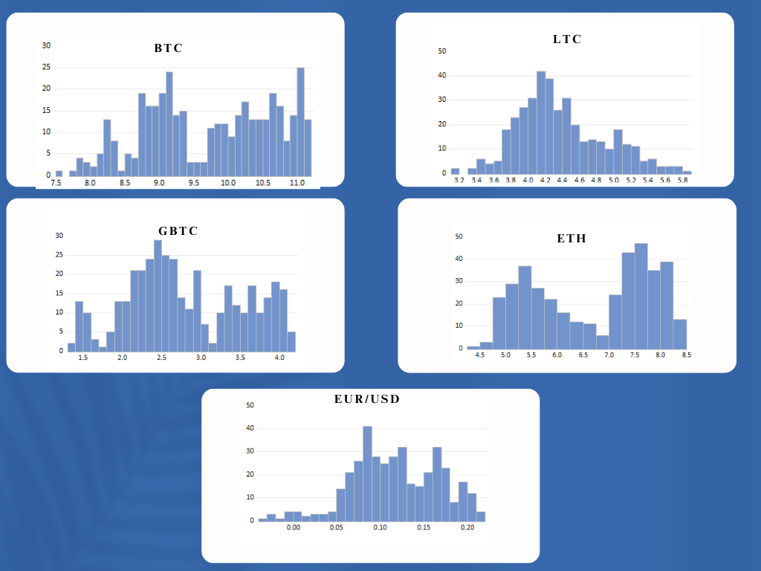

## Q-Q PLOTS:

### **NASDAQ**

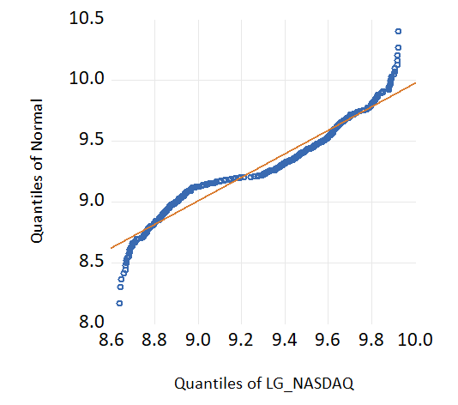

### **BITCOIN**

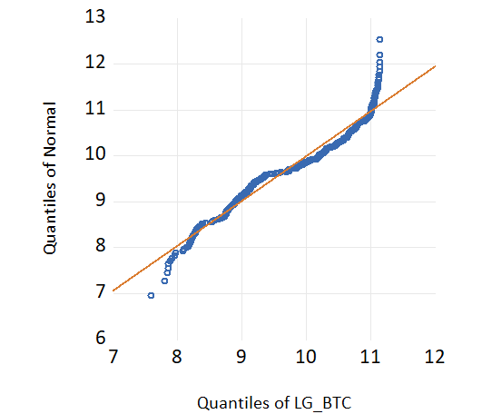

### **ETHEREUM**

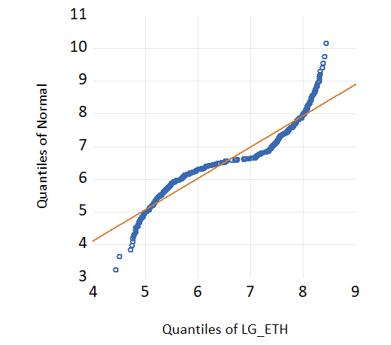

### **LITECOIN**

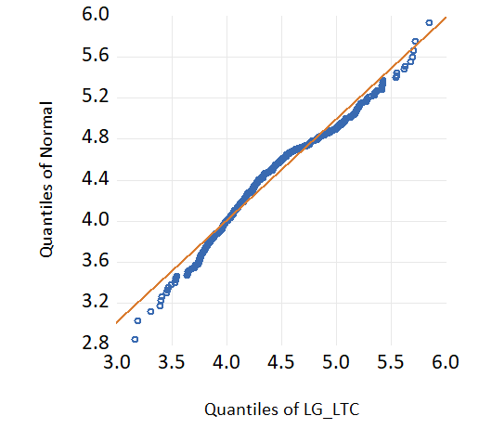

### **GBTC**

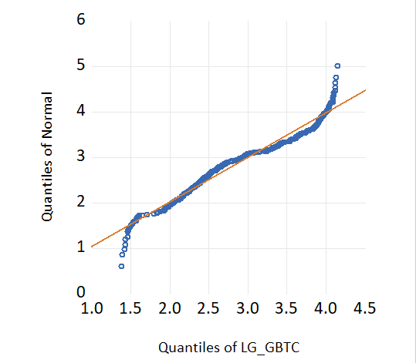

### **EUR/USD**

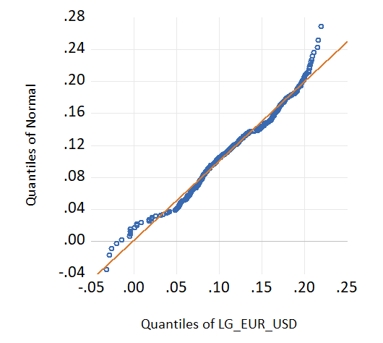

## JARQUE-BERA TEST:

Now we move on to the Jarque-Bera test, for this, we take estimate our model and then take the residuals and check their normality to see if they are normally distributed.

We go into E-views and estimate our model.

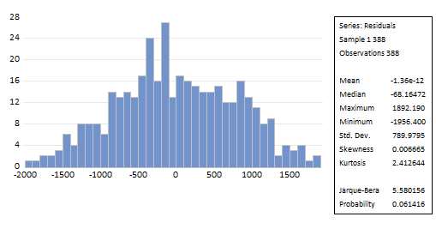

After estimating our model, we go into the descriptive stats and look the Jarque-Bera tabulated value and the probability of the residuals.

Here, the following two things need to happen to so that we can assess the following hypothesis.

**H₀: The residuals are normally distributed.**

**H₁: The residuals are not normally distributed.**

So, we look into the values given and compare them with what is a set standard, for the Jarque-Bera test we need the Jarque-Bera factor to be less than 1.76 and the probability value needs to be greater than 0.05.

In this case, we come to the conclusion that the residuals are in fact normal and we fail to reject the null hypothesis, which states, the residuals are normally distributed, and they follow a bell-shaped curve.

# CORRELATION ANALYSIS:

## CORRELATION MATRIX:



## CORRELATION MATRIX EXPLAINED:

For correlation, it explains the linear relationship between the variables and this is indicated by the values of the coefficients and it is ranged between -1 to 1 where:

* **+1**: Perfect positive correlation (as one variable increases, the other increases proportionally).
* **0**: No correlation.
* **-1**: Perfect negative correlation (as one variable increases, the other decreases proportionally).

## CORRELATION BETWEEN VARIABLES:

Now, after getting out results we will be explaining the correlation matrix and the values obtained from it as follows:

**NASDAQ vs. CRYPTOCURRENCIES CORRELATION:**

* **NASDAQ & BTC (0.925418)**:

There is a substantial positive link between the movements of the NASDAQ 100 and the weekly logarithmic returns of Bitcoin. This implies that there is a substantial correlation between the price trends of Bitcoin and the success of the stock market.

* **NASDAQ & ETH (0.859858)**:

Although not as strong as Bitcoin's, a substantial positive correlation indicates Ethereum's close link with the NASDAQ.

* **NASDAQ & LTC (0.163167)**:

A weak positive correlation, indicating Litecoin's movements are less synchronized with NASDAQ compared to other cryptocurrencies.

### **INTER-CRYPTOCURRENCY CORRELATION**:

* **BTC & ETH (0.895691)**:  
  Bitcoin and Ethereum share a **very strong positive correlation**, indicating that their price trends move in tandem most of the time. This is expected as they are the two largest cryptocurrencies by market capitalization and are often influenced by similar market dynamics, news, and investor sentiment.
* **BTC & LTC (0.4347440)**:  
  Bitcoin and Litecoin have a **moderate positive correlation**, meaning they share some similarities in price movements but are not as closely aligned as BTC with ETH or DOGE. Litecoin, being an earlier altcoin, may have its price influenced by unique factors (e.g., its use as a testbed for Bitcoin innovations).
* **ETH & LTC (0.448356)**:  
  Ethereum and Litecoin have a **moderate positive correlation**, indicating less price dependency compared to ETH’s relationship with BTC and DOGE. This suggests that Litecoin's market behavior is less influenced by Ethereum's trends.

# STATIONARITY OF VARIABLES:

**Stationarity at I (1) via ADF (Augmented Dicky Fuller) Testing:**

|  |  |  |  |  |  |
| --- | --- | --- | --- | --- | --- |
| **Time Series** | **ADF stat** | **at 1%** | **at 5%** | **at 10%** | **p-value** |
| **Nasdaq (NDX)** | -20.35719 | -3.982011 | -3.421508 | -3.133535 | 0.0000 |
| **Bitcoin (BTC)** | -18.31172 | -3.982011 | -3.421508 | -3.133535 | 0.0000 |
| **Ethereum (ETH)** | -15.47034 | -3.982074 | -3.421539 | -3.133553 | 0.0000 |
| **Litecoin (LTC)** | -17.59367 | -3.982074 | -3.421539 | -3.133553 | 0.0000 |
| **Grayscale Bitcoin ETF (GBTC)** | -17.46934 | -3.982011 | -3.421508 | -3.133535 | 0.0000 |
| **EUR/USD** | -22.17754 | -3.982011 | -3.421508 | -3.133535 | 0.0000 |

**After assessing these, we come to the conclusion that all the variables are stationary at first difference I (1).**

# MULTIPLE REGRESSION ANALYSIS:

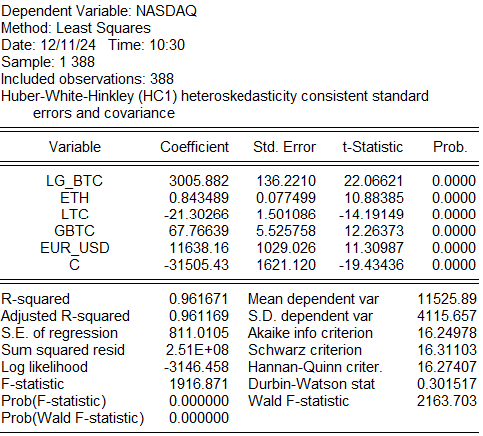

## Interpretation:

### **Coefficients:**

* **Intercept (C):** The constant term, -31505.43, represents the NASDAQ's predicted value when all independent variables are zero.
* **BTC (Bitcoin):** A coefficient of 3005.882 indicates that a 1-unit increase in BTC leads to a 3005.882 -unit increase in NASDAQ, holding other variables constant.
* **ETH (Ethereum):** A coefficient of 0.843489 suggests that a 1-unit increase in ETH results in a 0.843489 -unit increase in NASDAQ, holding other variables constant.
* **LTC (Litecoin):** A coefficient of -21.30266 indicates that a 1-unit increase in LTC leads to a 21.30266-unit decrease in NASDAQ, holding other variables constant.
* **GBTC (Grayscale Bitcoin):** A coefficient of 67.76639 suggests that a 1-unit increase in DOGE results in a 67.76639-unit increase in NASDAQ.
* **EUR/USD**: A coefficient of 11638.16 suggests that a 1-unit increase in DOGE results in a 11638.16-unit increase in NASDAQ.

***“A key thing to note here would be to understand that in order to get significant results, log of GBTC has been taken to make sure it does not give us problems later on like multi-collinearity and other problems.”***

### **Significance:**

**Individual Hypothesis**

* **Null Hypothesis (H₀):**
  + β1=0
  + β2=0
  + β3=0
  + β4=0
* **Alternative Hypothesis (H₁):**
  + β1≠0
  + β2≠0
  + β3≠0
  + β4≠0

**a. T-values:**

* **BTC:**
  + tcal​∣=22.06621>2 (benchmark).
  + We reject H0 and conclude that there is a significant relationship between NASDAQ and BTC.
* **ETH:**
  + tcal​∣=10.88385>2 (benchmark).
  + We reject H0 and conclude that there is a significant relationship between NASDAQ and ETH.
* **LTC:**
  + ∣tcal​∣=-14.19149>2 (benchmark).
  + We reject H0 and conclude that there is a significant relationship between NASDAQ and LTC.
* **GBTC:**
  + tcal​∣=12.26373>2 (benchmark).
  + We reject H0​ and conclude that there is a significant relationship between NASDAQ and GBTC.
* **EUR/USD:**
  + tcal​∣=11.30987>2 (benchmark).
  + We reject H0​ and conclude that there is a significant relationship between NASDAQ and EUR/USD.

**b. P-values at 5% level of significance:**

* **BTC:** p=0.0000<0.05, so we reject H0​ and conclude that there is a significant relationship between NASDAQ and BTC.
* **ETH:**p=0.0000<0.05, so we reject H0​ and conclude that there is a significant relationship between NASDAQ and ETH.
* **LTC:** p=0.0000<0.05, so we reject H0​ and conclude that there is a significant relationship between NASDAQ and LTC.
* **GBTC:** p=0.0000<0.05, so we reject H0​ and conclude that there is a significant relationship between NASDAQ and GBTC.
* **EUR/USD:** p=0.0000<0.05, so we reject H0​ and conclude that there is a significant relationship between NASDAQ and EUR/USD.

### **Model Fit:**

* **R² = 0.961671 or 96.1671%**  
  This indicates that **96.1671**% of the variation in NASDAQ is explained by BTC, ETH, LTC, and DOGE, while the remaining is explained by other factors not included in the model.
* **Adjusted R² = 0.961169**  
  This adjusted value accounts for the number of predictors in the model and confirms a strong model fit.

# DIAGNOSTIC TESTS

## MULTICOLLINEARITY

When independent variables in your regression model have a high degree of correlation with one another, this is known as multicollinearity, and it can skew the estimates of your regression coefficients.

### VARIANCE INFLATION FACTOR (VIF)

### TABLE FOR VIF

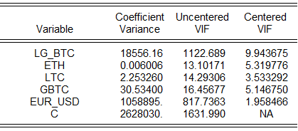

## EXPLANATION

**Interpreting VIF Values**

* **VIF < 10**: Indicates there is low multicollinearity and it's not a concern.
* **VIF > 10**: Suggests high multicollinearity and may require action to address it.

Here,

* **BTC**: The Centered VIF is 9.790880, which is below 10, indicating that BTC is not experiencing severe multicollinearity.
* **ETH**: The Centered VIF is 8.031357, which is below 10, suggesting that ETH has low multicollinearity and it is not a concern.
* **LTC**: The Centered VIF is 2.364753, which is well below 10, indicating no multicollinearity issue.
* **GBTC**: The Centered VIF is 5.452328, below 10, so there is no concern of multicollinearity.
* **EUR/USD:** The Centered VIF is 2.971264, below 10, so there is no concern of multicollinearity.

## HETEROSCEDASTICITY

When the variance of the residuals varies across all levels of the independent variables, this is known as heteroskedasticity. Hypothesis tests may become unreliable as a result of this violation of the homoscedasticity assumption.

Heteroskedasticity causes inefficient coefficient estimates and invalid standard errors, leading to unreliable t- and F-tests.

### **WHITE TEST**

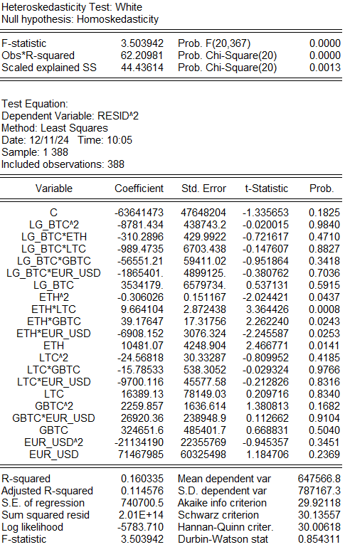

Since the p-value is less than 0.05, that means we accept the Null Hypothesis stating that there is heterokedasticity present in our model.

This infers that there is no constant mean and constant variance across the model.

However, in order to tackle this problem we will have used robust mean method to cater the issue of heteroscedasticity here.

It will be shown in an MLS output below after all the tests.

### 

### **BREUSCH-PAGAN-GODFREY TEST**

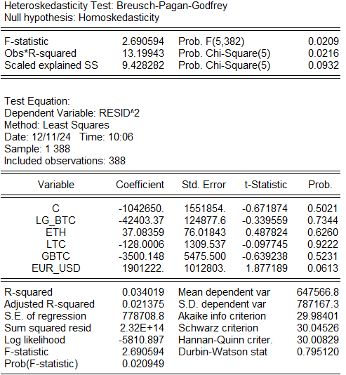

As we can see that the Chi-Squared Probability is greater than 0.05, this tells us that we should be accepting the Null Hypothesis and claiming that homoskedastcity exists in this model.

This infers that there is constant mean and constant variance across the model.

The functional form for this test will be:

**Resid^2 = C+ LG_BTC + ETH + LTC + GBTC + EUR_USD**

### **HARVEY TEST**

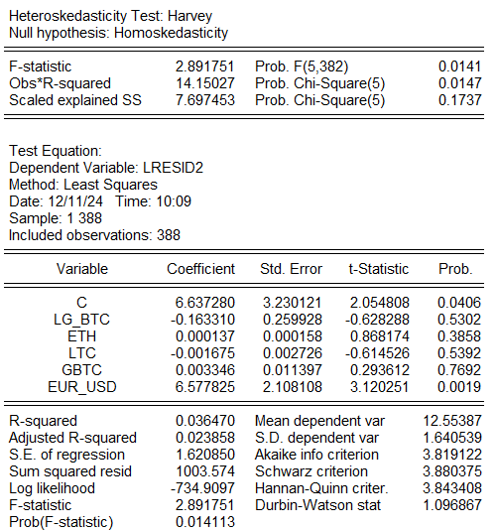

Here we also see that the Chi-Square Probability is greater than 0.05 which leads us to the conclusion that Heteroskedasticity does not exist in the model.

Harvey test is distinct as it tests Heteroskedasticity by estimating the model by taking logarithmic residual^2 as the dependent variable and keeping the other independent variables the same as the regular OLS ones.

The function form for this becomes:

**Log (Rsesid^2) =C + LG_BTC+ ETH + LTC+ GBTC + EUR_USD**

**As for the concern of White test and it not proving significant for homoscedasticity, we apply robust mean methods which makes an exception for the heteroskedasticity scenario.**

**Since, the white test is more robust and provides a non-parametric idea for heteroskedasticity, we apply robust mean method and use the following as our model, this will be used as our model which has its own VIFs (controlled) and the residuals are normal as well and the model is also consistent (will be proven in Ramsey RESET test)**

**We run the regular OLS model and make a few changes.  
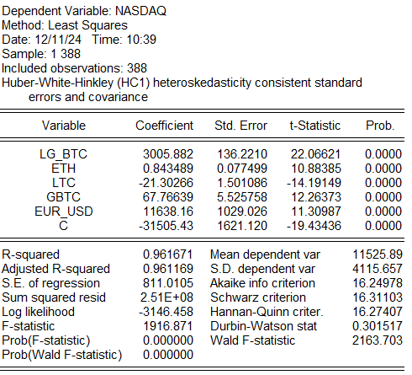**

**Here, it clearly explains that it caters for the heteroskedasticity consistent standard errors and covariance.**

## AUTOCORRELATION

When the residuals are not independent of one another, autocorrelation arises, which goes against the presumption that errors are random.

We can detect Autocorrelation in our model by running the following tests on our model.

### **DURBIN WATSON TEST**

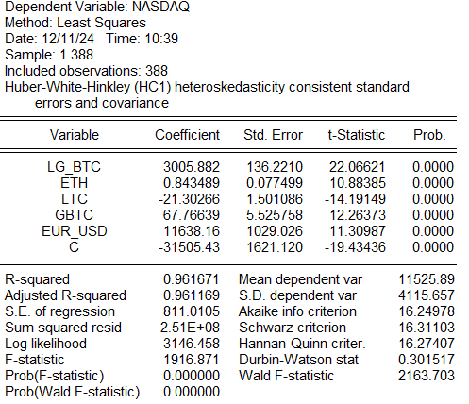

Here, we look at the Durbin Watson statistic and as we can see that it is close to zero which makes it near positive autocorrelation according to the following threshold:

**DW ≈ 2**: No autocorrelation.

**DW = 2**: Positive autocorrelation.

**DW = 4**: Negative autocorrelation.

Since, Heteroskedasticity exists here we go a step further to make our results more concise and consistent.

### **DURBIN WATSON -h TEST**

To apply Durbin h test, we use to following formula:

h= (1- d/2) **√**(n-1)/(1-n*var)

Here,

d= regular Durbin Watson stat (0.301517)

n= number of observations (388)

var = is the estimated variance of the coefficient of the lagged dependent variable (0.000731323849)

And to achieve these values we run the serial correlation LM test which gives us this answer.

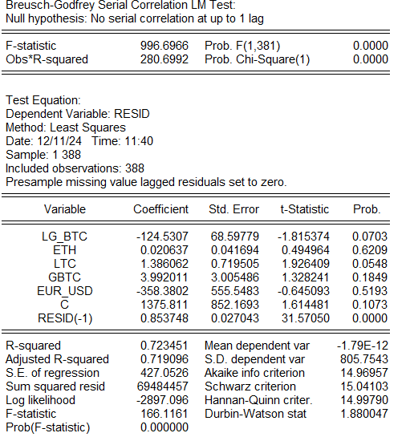

Now we take the values and get the h stat:

h= 14.138974417

Now, as the threshold gives us the reasoning that the lagged variable’s probability should be less than 0.005 and it is 0.0000,

AND

The h stat value is greater than 1.96 which gives us proof that serial correlation exists and we reject the Null Hypothesis saying:

**H0: No serial correlation at up to 1 lag.**

## Ramsey RESET Test

Now we apply the Ramsey RESET test in order to check any misspecifications in our model.

After application of the test, we get:

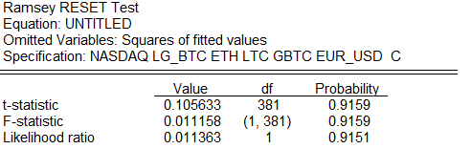

This table shows a p-value of 0.9151 which means that there is no misspecification in our model and this model is optimal.

### **CORRELOGRAM OF RESIDUALS**

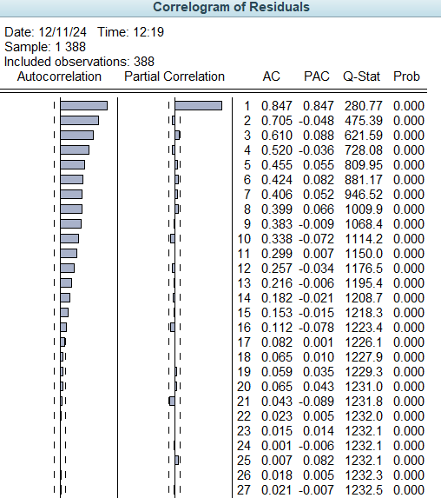

The result of the correlogram shows us that autocorrelation exists in our model, this explains that the residuals are not independent of each other which leads us to believe that the lagged variables are connected and it is by one another.

We look at the p-value here, it is visible that they are less than 0.05 which indicates the presence of Autocorrelation.

Generally, autocorrelation can never be zero in a model as dependency of events across the model is something which is inevitable.

As autocorrelation is present in our residuals:

1. **Include Lagged Terms**:
   * Add lagged dependent or independent variables to the model.

This would be our go to remedy to decrease the autocorrelation problem.

As this can create this problem:

**“Autocorrelation invalidates standard errors and makes coefficient estimates inefficient.”**

After including lagged term AR (1) in our model we found out that the autocorrelation controlled and there is no fluctuated spike in the ACF PACF.

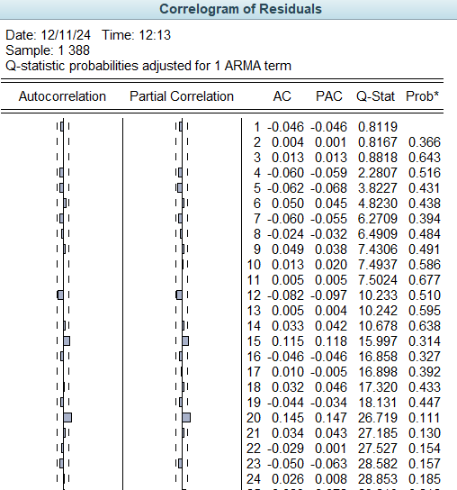

### **JOHANSEN CO-INTEGRATION TEST**

As the variables are all stationary at first difference I (1), we use the Johansen Cointegration test and see the long-term relationships in our model. As the Ramsey RESET test also showed that there are no misspecifications in our model, this model is sound to be tested by the Johansen Cointegration Test.

### **TRACE TEST**

|  |  |  |  |  |
| --- | --- | --- | --- | --- |
| **No of CE's** | **Eigenvalue** | **Trace Stat** | **0.05 Critical Value** | **Prob** |
| **None\*** | 0.237912 | 195.155 | 103.8473 | 0.0000 |
| **At most 1\*** | 0.105792 | 90.55312 | 76.97277 | 0.0032 |
| **At most 2** | 0.054954 | 47.50341 | 54.07904 | 0.1692 |
| **At most 3** | 0.034845 | 25.74259 | 35.199275 | 0.3565 |
| **At most 4** | 0.019229 | 12.08813 | 20.26184 | 0.441 |
| **At most 5** | 0.01191 | 4.612992 | 9.164546 | 0.3285 |

After the Johansen Cointegration test is applied, we look at Trace Test here which tells us how many cointegrating equations exist.

According to the trace test, we can see that there are at most 2 co-integrating equations.

This output from E-views gives the trace test table. Trace test indicates 2 cointegrating eqn(s) at the 0.05 level.

### **RANK TEST**

In the rank test, we look at the maximum Eigen Value and look at our table and see for cointegrating equations.

|  |  |  |  |  |
| --- | --- | --- | --- | --- |
| **No of CE's** | **Eigenvalue** | **Trace Stat** | **0.05 Critical Value** | **Prob** |
| **None\*** | 0.237912 | 104.6019 | 40.9568 | 0.0000 |
| **At most 1\*** | 0.105792 | 43.04971 | 34.80587 | 0.0042 |
| **At most 2** | 0.054954 | 21.76083 | 28.58808 | 0.2897 |
| **At most 3** | 0.034845 | 13.65445 | 22.29962 | 0.4941 |
| **At most 4** | 0.019229 | 7.47514 | 15.8921 | 0.6113 |
| **At most 5** | 0.01191 | 4.612992 | 9.164546 | 0.3285 |

Max-eigenvalue test indicates 2 cointegrating equations at the 0.05 level.

“*” denotes the rejection of the hypothesis at the 0.05 level.

Now, we look at the cointegrating equation:

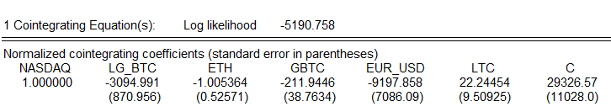

Here, we can obtain the t-stat values from this table and see if the variables are significant or not which in this case are significant, which tells us that there exists a long-term relationship between our variables in the model one way or another.

## **Vector Error Correction Model (VECM)**

In order to see our model exhibits long-term relationship, we need to see if the ECT (Error Correction Term) is stationary at level I (0) and all the other variables are stationary at first difference. So, we run the stationarity test on our error term and we find out that:

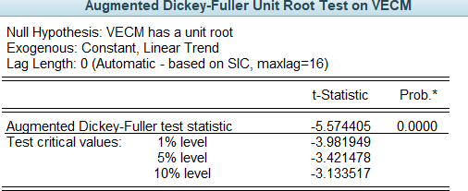

Here the value is significant and we reject the null hypothesis which states, VECM has a unit root, this means that our error correction term is stationary at level and therefore exhibits a long-term relationship in our model.

## **Granger Casualty Test**

Now, we move onto the next thing, which is Granger Casualty Test which we obtained from E-Views as follows.



This table explains how the variables have predictive causality between one another, these results show if the causal relationship is bidirectional, no causality and unidirectional causality and it can be measured based on the following criteria.

H0: There is no Granger Cause.  
H1: There is Granger Cause.

If the p-value is less than 0.05 then we reject Ho and if it is greater than 0.05, there is a granger cause.

# MODEL SELECTION:

## **ARMA/ARIMA Modelling**

So, for the selection of ARMA/ARIMA models, there is a procedure that needs to be followed to get there, we incorporated the following steps for the model selection.

We will be assessing Nasdaq (NDX) for the modelling basis. Since we used the log values in the normality procedure, we will take log of NDX.

Before the procedure, the rule of thumb for ARMA/ARIMA model is as follows:

## **INSTRUCTIONS:**

### **Model Selection (ARMA vs. ARIMA):**

* **ARMA (p, q)**: Use when the time series is stationary (no trends or seasonality).
* ARIMA (p, d, q): Use when the time series is non-stationary (trend or seasonality present). The "d" (differencing) removes non-stationarity.

### **Checking Stationarity:**

* Use the **Augmented Dickey-Fuller (ADF) test** or **visual inspection**.
  + If p>0.05, the series is non-stationary → Apply differencing (d).
  + If p≤0.05, the series is stationary → No differencing needed (d=0).

### **Parameter Selection:**

* Autoregressive (AR, p): Determine from the Partial Autocorrelation Function (PACF).

1. Significant spikes at lag k in the PACF suggest AR terms up to p=k.

* **Moving Average (MA, q)**: Determine from the **Autocorrelation Function (ACF)**

1. Significant spikes at lag k in the ACF suggest MA terms up to q=k.

* **Differencing (d)**: Number of times the series is differenced to achieve stationarity.

1. Start with d=1 and test stationarity after each differencing.

## **APPLICATION:**

### **Nasdaq (NDX):**

We took log (NDX) first, and we checked the stationarity:

At level I (0):

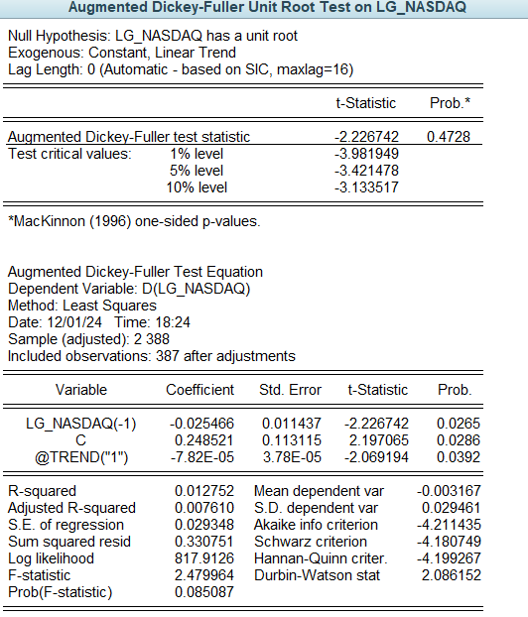

Since it proves to be insignificant as the p-value is greater than 0.05 and the tabulated value is also less than the critical values.

At First Difference I (1):

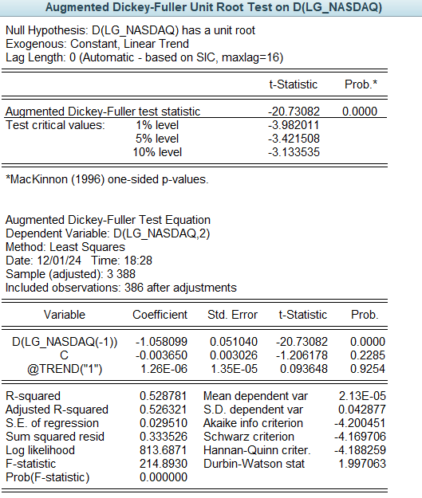

As the p-value is significant, being less than 0.05 and the tabulated value is also greater than the critical values, this shows us that the series is stationary at first difference.

By having our series stationary at first difference, we come to the conclusion that we will have an ARIMA model which is going to be ARIMA (p ,1, q) model.

Now,

We take the differenced series and run a correlogram on it.

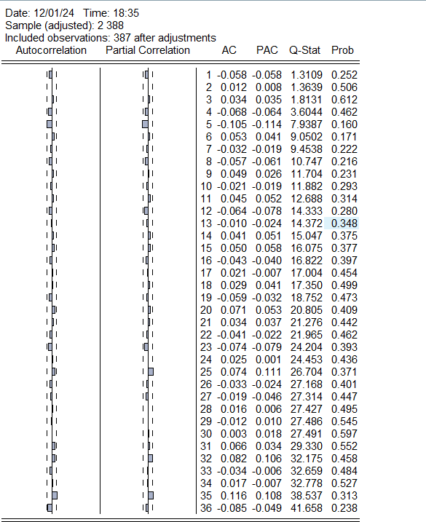

Looking at significant spikes we see that,

AR (5) & MA (5)

AR (35) & MA (35)

These will turn into:

**ARIMA (5,1,5)**

**ARIMA (35,1,35)**

Now, we check these models by running them on E-views by estimating them one by one.

### **ARIMA (5,1,5)**

By estimating:

**d (lg_nasdaq) ar (5) ma (5) c**

**we get:**

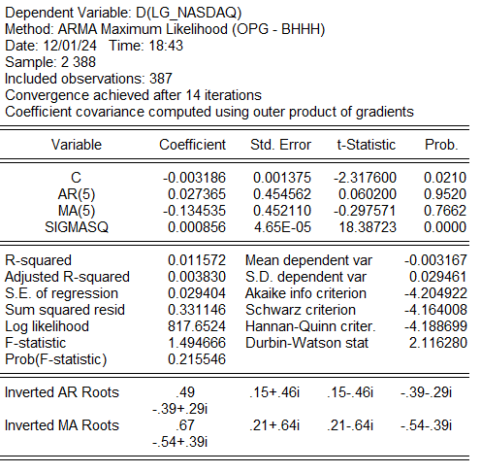

**Findings:**

From this estimation we see that the AR and MA variables are not significant at all so we cannot be using this model.

### **ARIMA (35,1,35)**

By estimating:

d(lg_nasdaq) ar(35) ma(35) c

we get:

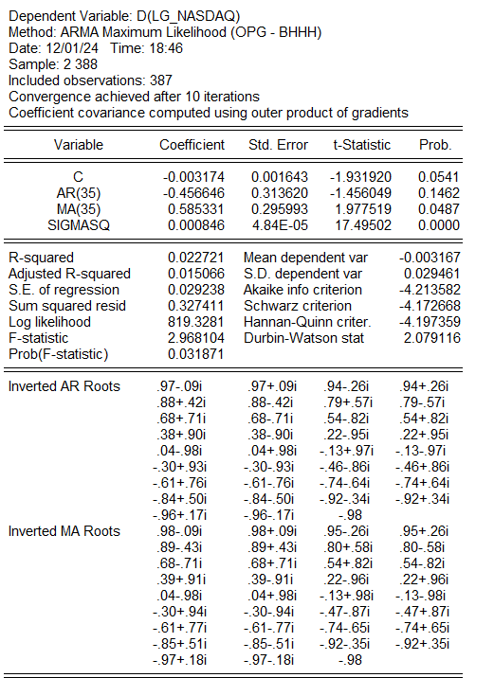

**Findings:**

We see here that only the MA variable is significant and we AR is not.

To move forward, we make sure to use a combination of both to see how it plays out, by keeping the MA (35) and replacing the AR (35) with AR (5).

### **ARIMA (5,1,35)**

By estimating:

d(lg_nasdaq) ar(5) ma(35) c

we get:

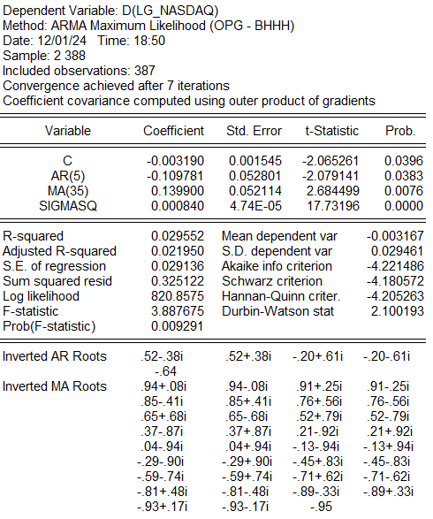

**Findings:**

Here, we get both AR and MA to be significant and hence we can use this as our model for forecasting and moving on to the next steps.

## **FORECASTING:**

Moving on to the next step, we will be forecasting another period for the model we selected.

We select the forecasting option from e-views and then:

We get these results:

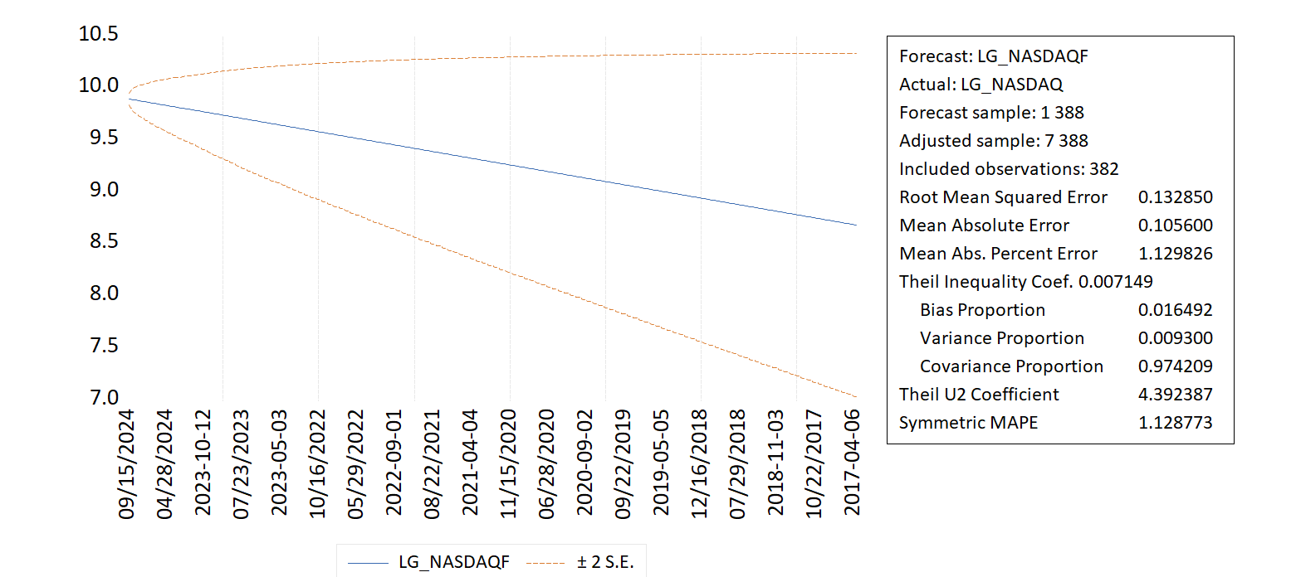

The forecast gives us the following the insights:

### **GRAPH EXPLANATION**

The ARMA/ARIMA model's predicted values (blue line) and 95% confidence interval (dashed orange lines) for the variable LG_NASDAQ are displayed in the chart. Using historical data up to the most recent observation, a forecast is created for the future (starting in September 2024).  
  
The forecasted values stretch from the most recent observation, displaying the anticipated values for the future, while the blue line represents the actual data**.**

### **CONFIDENCE INTERVAL:**

The range that the actual future numbers are expected to fall within is represented by the dashed lines surrounding the forecast, which are the 95% confidence interval (± 2 Standard Errors). As the confidence interval around the predicted line gets smaller, the forecast's dependability rises.

### **TABLE EXPLANATION**

* RMSE, or root mean squared error

0.132850 means that, on average, there is a 0.1328-unit difference between the predicted and actual values. The better the model fits the data, the lower the RMSE.

* Mean Absolute Error

0.105600 indicates that there is an average absolute error of 0.1056 units between the predicted and actual values.

* Mean Absolute Percentage Error

1.129826% indicates that, on average, there is a 1.13% discrepancy between the predicted and actual values. Good forecasting performance is indicated by this comparatively low percentage.

* Theil U2 Coefficient

A relative indicator of predicted performance is 4.392387. Although the model's performance might yet be enhanced, a result nearer 1 would signify perfect predictions.

# CONCLUSION:

This study examined the effect of cryptocurrency markets on traditional stock market indices using a comprehensive multiple regression analysis of volatility and correlation. By using GBTC ETF data to reflect institutional engagement, the study provided deep insights into the growing relationship between these two financial sectors.

Significant findings revealed a robust correlation between cryptocurrency volatility and shifts in traditional stock indices, pointing to a shifting dynamic fueled by increased institutional participation. The results demonstrate how cryptocurrencies are altering investment strategies and market dynamics.

Future research could expand on these findings by utilizing larger datasets, looking into alternative institutional proxies, and analyzing how specific macroeconomic events affect the relationships between cryptocurrencies and the stock market. Examining geographic variations in these relationships may also yield a deeper understanding of regional market dynamics.

This study concludes by emphasizing the importance of understanding the integration of new financial products into current markets, which paves the way for more informed frameworks for investment and regulatory decisions.

# REFERENCES:

Following were the links used to gather data for our study:

<https://www.investing.com/indices/nq-100>

<https://www.investing.com/crypto/bitcoin/btc-usd-historical-data>

<https://www.investing.com/crypto/ethereum/eth-usd>

<https://www.investing.com/crypto/litecoin/ltc-usd>

<https://www.investing.com/crypto/dogecoin/doge-usd>